Members: **ZOHAIB HASSAN, SYED AHMED SHAH**

RollNos#: **19SW42, 19SW44**

Subject: **MAD (final project report)**



**Problem:**

You want to buy an item for your makeup which can be anything, lipstick, eyeliner, blush, Nail polish or a foundation, if talking about an app then you will go to an online store app/ecommerce app, where you will need to search & find the exact product, which can be a time consuming task, so there should be an app which offers only makeup products to buy.

**Proposed Solution:**

The proposed solution is an application named "MakeupApp" where people (or more specifically women) can buy any product that fall in the category of makeup. The MakeupApp can be used after user registration which can be done in two ways(email-password or Google) and authentication. The app is very easy to use and is very user-friendly. The app also provides the cart functionality so that if the user wants to buy products later then all he/she needs to do is to add those products to cart. The customer can filter the products by brand or category (lipstick, nail polish etc.).

**Screen Shots:**

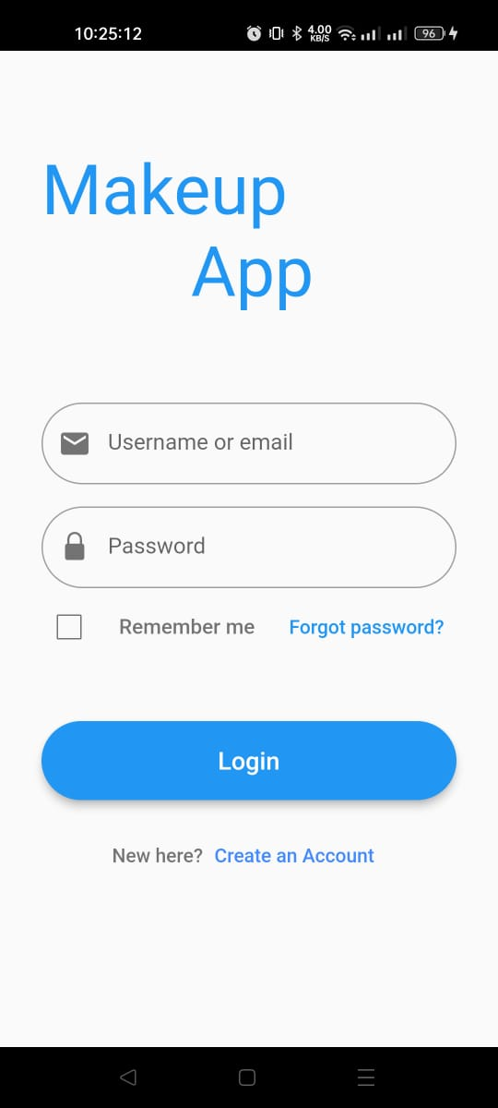

**Data Storage:**

For storing the user registration information, this project uses firebase which provides in-built functionality to register users and process login sessions. For storing information of products that are added to cart the app uses SQLite database. As this data is small, and for small data Flutter itself recommends to use SQLite database which is what this app uses. The app also uses shared preferences to store the login status of user i.e., if user is logged in or logged out.

The makeup products data shown in app is fetched from the following API:

https://makeup-api.herokuapp.com/api/v1/products.json

The app uses many packages and plugins to implement reusability. Following packages/plugins are used in the MakeupApp:

**Package/Plugin Usage**

**badges**: To show the user how many items have been added to cart

**provider**: To access cart items throughout app screens. The State Management is implemented via this package.

**http**: to fetch the products data

**loading_overlay:** to show some loading widget when a process is in progress (E.g login/signup/loading products data)

**url_launcher:** to redirect user to buy now page of product.

**sqflite**: SQLite database to store cart data

**firebase_core:** provides firebase core functionalities

**flutter_slidable**: used to implement sliding actions in list tiles

**flutter_spinkit**: to use special loading widgets

**email_validator:** to email email entered by a user

**firebase_auth:** to authenticate the user via firebase

**shared_preferences:** to store the login status

**flutter_native_splash:** to implement splash screen

**Issues and Bugs Encountered and Resolved during Development:**

While development some issues regarding parsing of products data that was fetched from the API, were encountered, as some products were holding null values for some attributes, but later those were resolved with null aware technique.